

Coupon Offer for FTTH New Connections Solution

Functional Requirement Document

Document Number : BPMS XXXXXXX

Issue No : V 1.0

Issued on : 14 Feb 2024

Issued by : BPM Section

.

Document Control Sheet

**Contact for Inquiries & Proposed Changes**

Name : Bandula Wimalasuriya

Designation : DGM/BPM

Telephone : 0714217858

E-mail : badwim@slt.com.lk

Prepared By

|  |  |  |  |
| --- | --- | --- | --- |
| Name | Designation | Date | Signature |
| Dinusha Rajapaksha | Senior Engineer/ BPM |  |  |
| Nilushka Rathugama | Engineer/ BPM | 14 Feb 2024 |  |

Reviewed By

|  |  |  |  |
| --- | --- | --- | --- |
| Name | Designation | Date | Signature |
| Nishani Weerasinghe | GM/Product Development & Management |  |  |
| Suraj Peiris | GM/Business Support & AI |  |  |
| Janaka Harambearachchi | GM/Digital Platform |  |  |
| Pasan Nishantha | GM/System Integration and Operations |  |  |
| Bandula Wimalasuriya | DGM/ Business Process Management |  |  |
| Ayoma Wickramarachchi | DGM/ Product Development & Management (BB) |  |  |
| Kosala Tennakoon | DGM/ Digital Platform  Development |  |  |
| Praneetha Ramachandran | DGM/SI & Automations |  |  |
| Samitha Sagara | DGM/IT Solution Development |  |  |
| Kushan Samarasinghe | DGM/Channel Management |  |  |
| Krishanthi Senevirathna | DGM/ Product Development & Management (Voice) |  |  |
| Sampath Jayakody | Eng/ CRM Development & Deployment |  |  |

Approved By

|  |  |  |  |
| --- | --- | --- | --- |
| Name | Designation | Date | Signature |
| Prabath Dahanayake | CMO |  |  |
| Imantha Wijekoon | CO-CBO |  |  |
| Tilak Gamalath | CTO |  |  |

Revision History

|  |  |  |  |  |
| --- | --- | --- | --- | --- |
| **Issue Number** | **Issued Date** | **Issued By** | **Summary of Changes** | **Document Section** |
|  |  |  |  |  |
|  |  |  |  |  |

# Table of Contents

Table of Contents iii

1.0 Introduction 4

2.0 Voucher Management System (VMS) 6

3.0 Proposed End to End Solution 7

4.0 Proposed SOA and API Integrations 13

5.0 New IT Capability Requirement 14

5.1 New Capability Requirement in CRM 14

# Introduction

The FRD outlines the key objectives and functional requirements for the implementation of a Coupon Selling process aimed at promoting Fiber-to-the-Home (FTTH) services, as per the directive from the Product Development team. However, the solution is also designed to facilitate the future requirements of the other voucher management requirement of SLT. The E2E process includes two marked sub-processes, each designed to facilitate efficient voucher management and redemption for FTTH new connections.

* 1. **Voucher Distribution Management:**

This sub-process entails the sale and distribution of vouchers, which will be managed through ERP System. While no new IT developments are required, configuration adjustments within these systems are necessary to seamlessly integrate the Coupon Selling process. The primary objective is to optimize the voucher distribution workflow, ensuring accuracy, transparency, and efficiency in voucher sales operations.

* 1. **Redeem Coupon for FTTH New Connections:**

Recognizing the limitations of the ERP system in handling coupon redemption for FTTH new connections, the solution involves repurposing the Voucher Management System developed by the Digital Platform team for SME business endeavors. This system will serve as the backbone for facilitating the redemption process, and streamlining customer onboarding for FTTH services. By leveraging existing technology infrastructure, the goal is to enhance operational efficiency and provide a seamless experience for customers redeeming coupons.

Through the successful implementation of these sub-processes, the organization aims to achieve the following objectives:

* Increase promotion and uptake of FTTH services through targeted coupon selling strategies as the immediate business requirement.
* Improve operational efficiency in voucher distribution and redemption processes.
* Enhance customer experience by providing a seamless and user-friendly coupon redemption process.
* Optimize resource utilization by repurposing existing IT solutions for voucher management.

Overall, the FRD serves as a blueprint for the development and implementation of the Coupon Selling process, outlining the functional requirements and objectives essential for achieving success in promoting FTTH services. It emphasizes the importance of leveraging existing technology infrastructure while aligning with organizational goals and customer needs.

# 2.0 Voucher Management System (VMS)

Since it is difficult to handle this process in ERP, we are seeking to reuse the Voucher Management System already developed for SME business by the Digital Platform team including minimum developments. For that, it requires the following capabilities and requirements in VMS.

1. The VMS table shall have the following minimum parameters.

**Voucher ID| Coupon ID| Coupon Offer Name| Coupon Activated Date| Coupon Issued Date| Coupon Expire Date| Coupon Face Value| Coupon Status | Validity period**

1. VMS has to validate the coupon by the Coupon ID and Coupon Status. Coupon Status will have the following status.

**Active| Reserved| Issued| Expired| Cancel| Inactive| Abounded| Allocated**

1. VMS support to change the status from **Active -> Reserved -> Issued** by the external triggers. If cancellation API calls, **Reserved -> Active** status back. Or From any status to ‘Cancel’ or ‘Abounded’ status.
2. VMS has to run its own process daily and change the Coupon Status to ‘**Expired**’ if the expiration date has passed.
3. Admin account has to be developed/Configured to Maintain Create, Modify, and Delete records in VMS table.
4. Provision of a comprehensive dashboard view, facilitating real-time monitoring and analysis of data within the VMS table.
5. Facilitating the insert Data into the VMS Table.
6. Required to provide APIs for external triggers from SOA, ERP, Cashiering, CRM etc. based on the requirements.
7. Required to data synchronize from ERP to VMS.
8. Facilitating batch-wise download option: Once a coupon batch is allocated from the VMS, there should be an option to download the allocated list in Excel and Pdf format batch-wise with a security key.
9. Following Project Status, Batch Status, Voucher status, and Coupon status matrix shall be maintained in VMS.

|  |  |  |  |
| --- | --- | --- | --- |
| **Project Status** | **Batch Status** | **Voucher status** | **Coupon status** |
|  |  |  |  |
|  |  |  |  |
|  |  |  |  |
|  |  |  |  |
|  |  |  |  |

1. The VMS system should have email notification generation capability for each task.
2. The validity period starts once the voucher is issued from the ERP.(In automated process)
3. A transfer option for pending items or project orders should be facilitated.

# 3.0 Proposed End to End Solution

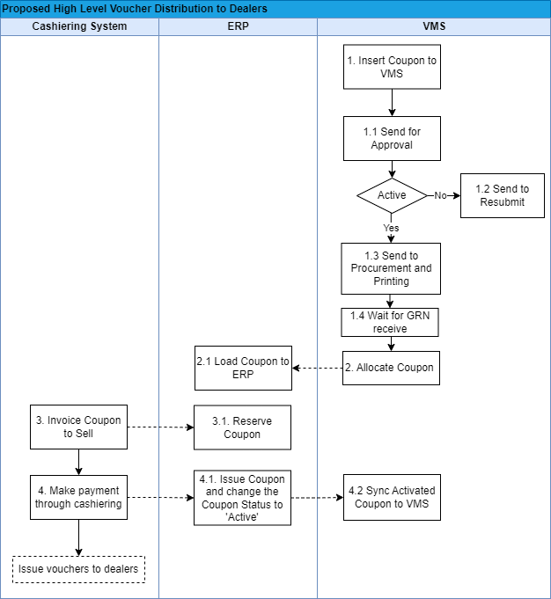

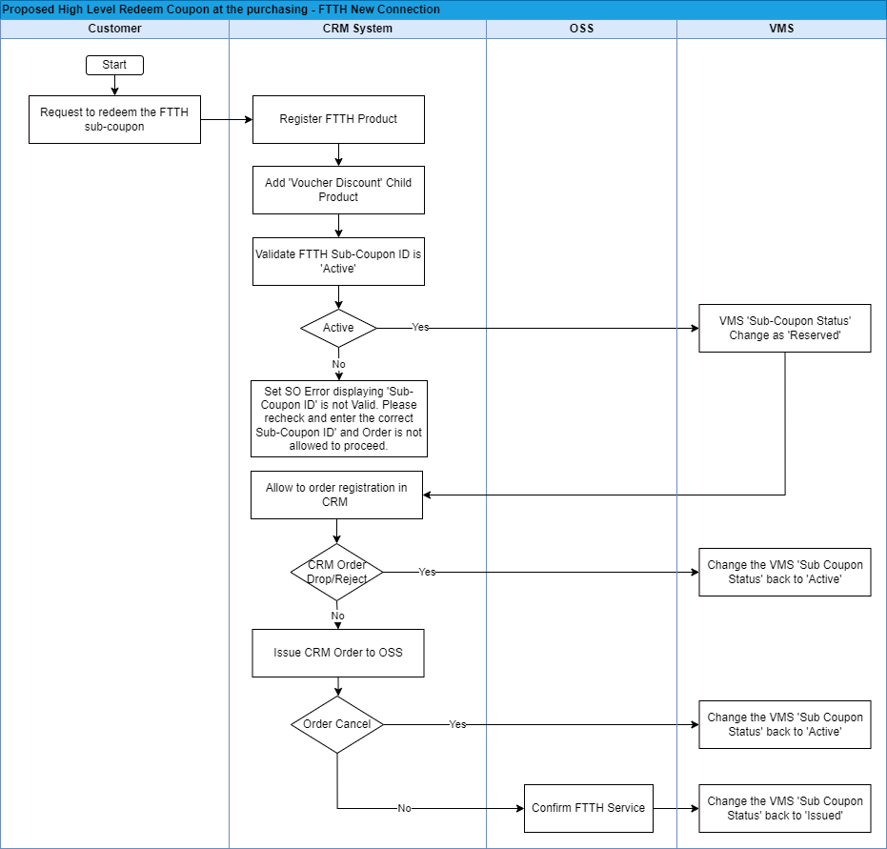

3.1 **Key functionalities/Activities**

|  |  |  |  |  |
| --- | --- | --- | --- | --- |
| **Function/Activity** | **Description** | **Input/Outputs** | **Integrated Systems** | **Business Rules/ Remarks** |
| Proposed High level Voucher Distribution to Dealers | | | | |
| 1. Insert Coupon to VMS | Upload Coupon-related details one by one or in Bulk to VMS.  Also, Users can enter coupon codes manually or through a digital interface. | Inputs  Voucher ID|  Coupon ID| Coupon Offer Name|  Coupon Issue Date|  Coupon Activated Date  Coupon Expire Date|  Coupon Face Value|  Coupon Status| | VMS | The system shall facilitate the Bulk Upload of Data to the VMS Table.  The character limitation for CRM is 100 characters. Therefore, for both ERP and CRM, the Coupon ID's character limitation should be 100 characters.  Voucher ID:  (Generated from the VMS side and character limitation is 100)  Coupon ID:  (Generated from the VMS side and character limitation is 100) |
| 1.1 Send for Approval | Once the project is created and submitted, it should go to the relevant approval officer.  The approval officer has two options: either reject or approve.  If approved, it goes to the procurement officer. If rejected, it triggers a 'Send to Resubmit' task and notifies the customer. | Inputs  Remarks | VMS |  |
| 1.2 Send to Resubmit | The project manager can see the status of the project and, based on that, must reinitiate the batch. | NA |  |  |
| 1.3 Send to Procurement and Printing | Send an email with a URL, file security key, and reference ID to the relevant officer (procurement officer). They can download the file and send it to the print vendor. | NA | VMS |  |
| 1.4 Wait for GRN receive | Until the Goods Received Note (GRN) is issued, this should remain pending with the relevant project manager. Once it is received, the project manager should complete the task. | Inputs  GRN Receive date  Remark  Reference | VMS |  |
| 2. Allocate Coupon | Allocate coupons from VMS and send them to the ERP to issue out. | Inputs  Voucher ID|  Coupon ID| Coupon Offer Name|  Coupon Issue Date|  Coupon Activated Date  Coupon Expire Date|  Coupon Face Value|  Coupon Status| | VMS | Inactive Status should be changed as allocated in VMS. |
| 2.1. Load Coupon to ERP | Load the **allocated** coupon to ERP from VMS. | Inputs  Voucher ID| | ERP | The Voucher ID should only be uploaded to the ERP.  On the VMS side, there should be a facility to download the Voucher IDs for store users. |
| 3. Invoice Coupon to Sell | Generate Invoice to sell. |  | Cashiering System |  |
| 3.1. Reserve Coupon | Reserve coupons for Dealers. | Dealer Name| Mobile Number | ERP |  |
| 4. Make payment through cashiering | Dealers have the option to collect Vouchers by making payments through the cashiering system, where they can interact with Coupon Managers. |  | Cashiering System |  |
| 4.1. Issue Coupon and Change the Coupon Status to 'Active' | The system enables the coupon manager to upload coupons and subsequently update the Coupon status to 'Active,' by ensuring that these coupons are already distributed to dealers.  These activated coupon details should be synced to the VMS system. | Inputs  Coupon ID|  Coupon Status | ERP/VMS | The system shall facilitate to select the Coupon IDs in ‘Pending’ status and change to the ‘Active’ status. |
| 4.2 Sync Activated Coupon to VMS | Synchronize the activated coupon list from ERP to VMS | Inputs  Coupon ID | ERP/VMS | The data view will be provided from the ERP side, and by referencing that, the VMS will update the list of activated coupons. |
| Proposed High-level Redeem Coupon at the purchasing – FTTH New Connection | | | | |
| **Function/Activity** | **Description** | **Input/Outputs** | **Integrated Systems** | **Business Rules/ Remarks** |
| Request to redeem the FTTH Coupon | Request the customer to redeem the FTTH New connection Coupon by visiting to the SLT RTOM office. |  | NA |  |
| Register FTTH Product | Register FTTH New Connection process in CRM. | Mandatory and required attributes for FTTH Product registration. | CRM |  |
| Add 'Voucher Discount' Child Product | Configure a new child product ‘Voucher Discount’ under FTTH product and Add it. |  | CRM |  |
| Validate FTTH Coupon ID is 'Active' | CRM user scans and updates the ‘Coupon ID’ in the product attribute and sends it to VMS.  Validate FTTH Coupon ID is in 'Active' status.  If the FTTH Coupon ID is in 'Active' status, then the VMS table 'Coupon Status' should be updated/ changed to 'Reserved' and passed the latest status to CRM. | Inputs  Coupon ID  Outputs  _Coupon Offer Name  _Coupon Face Value  _Coupon Status [ SUCCESS|FAIL]  _Status Description | CRM/VMS/  SOA | The following parameters should be returned once the provided Coupon ID is in ‘Active’ status.  _Coupon Offer _Coupon Offer Name  _Coupon Face Value  _Coupon Status [ SUCCESS|FAIL]  _Status Description  Otherwise, return the ‘FAIL’ request and the ‘Coupon Status’.  . |
| VMS 'Coupon Status' Change as 'Reserved' | If the FTTH Coupon ID is in 'Active' status, then the VMS table 'Coupon Status' should be updated/ changed to 'Reserved' and passed the latest status to CRM. | Coupon ID | VMS |  |
| Allow to order registration in CRM | If the FTTH Coupon ID is in 'Active' status, then allow to order registration in CRM. | NA | CRM |  |
| Change the VMS 'Coupon Status' back to 'Active' | If the order is rejected, Canceled, or dropped from the CRM, then the VMS table 'Coupon Status' should be updated/ changed back to 'Active' status. | Order Cancel request | VMS/CRM  /SOA | This scenario shall cover both order is dropped by CRM before submission to OSS and also the order is cancelled by CRM after order is submitted to OSS |
| Issue CRM Order to OSS | Submit the CRM order to OSS. | NA | CRM |  |
| Confirm FTTH Service | Completion of OSS SO. | NA | OSS | Once this is completed, OSS should trigger API 04 to update the VMS status. |
| Change the VMS 'Coupon Status' to 'Issued' | Once the OSS service order is completed, then the VMS table 'Coupon Status' should be updated/ changed to 'Issued' status based on the CRM Status. | Order completion status | VMS/CRM |  |

**3.2 Other functionalities in VMS**

|  |  |
| --- | --- |
| **Function** | **Description** |
| Change the VMS 'Coupon Status' to ' Expired’ | VMS has to run its own process daily and change the Coupon Status to ‘Expired’ if the expiration date has passed. |
| Dashboard view | Provision of a comprehensive customizable dashboard view, facilitating real-time monitoring and analysis of data within the VMS table including:   * **Overview of Voucher Usage**: Display an overview of voucher usage, including the total number of vouchers Active, Reserved, Issued, and Expired. * **Value of the Vouchers in VMS**: Total value of the Vouchers in VMS based on Coupon Offer Name and Status * **Redemption Trends:** Show trends in voucher redemption over time, including daily, weekly, or monthly redemption rates. * **~~Customizable Reporting~~**~~: Allow users to generate customizable reports.~~ |
| User Privileges and Authentication | The **Coupon Manager User Account** has to be developed to Maintain the Create, Modify, and Delete records in the VMS table. Also, create roles for each user and grant privileges to view different dashboards.  The **Normal User Account** has to be developed to view the **user Role-wise** Data, Dashboards and report generations.  For **External users** Authentication can be done via Gmail or Facebook. Also, create roles for each user and grant privileges to view different UIs. |
| Bulk Upload Data to the VMS Table | Facilitating the Bulk Upload of Data to the VMS Table manually (Using an Excel File) or through a digital interface.  Additionally, there should be a capability to edit coupon-related details individually only by the Business Admin User |

# 4.0 Proposed SOA and API Integrations

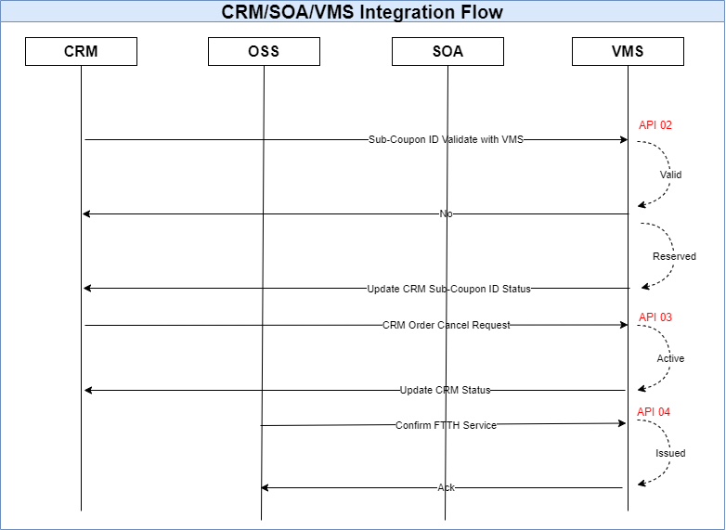

|  |  |  |  |
| --- | --- | --- | --- |
| **API Number** | **Description** | **Inputs** | **Output** |
| API 01  (Check coupon status) | Coupon validation –IF Status is ‘active’, then Output should be SUCCESS. | Coupon ID (XXX-XXX-XXX) | _Coupon Offer Name  _Coupon Face Value  _Coupon Status [ SUCCESS|FAIL]  _Status Description |
| API 02  (Coupon reservation.) | Coupon reservation.  If Status is ‘active’, then Output should be SUCCESS. | Coupon ID  Order Number  Product Type  Order create Date & Time | _Coupon Offer Name  _Coupon Face Value  _Coupon Status [ SUCCESS|FAIL]  _Status Description |
| API 03  (Coupon cancel) | Coupons revert to active (Order Cancel request)  Reserved -> Active | Coupon ID | _Coupon Status [ SUCCESS|FAIL]  _ Status Description |
| API 04  (Service Confirm) | Coupon redemption. Reserved -> Issued | Coupon ID | _Coupon Status [ SUCCESS|FAIL]  _ Status Description |

# 5.0 New IT Capability Requirement

## 5.1 New Capability Requirement in CRM

***5.1.1 Grand Child Product Configuration for AB_Fiber Access Bearer and E_SLT Peo TV Service***

Configure a new grandchild product ‘AB_Voucher Discount’ under the AB_Fiber Access Bearer as below.

Configure a new grandchild product ‘E_Voucher Discount’ under the E_SLT Peo TV Service as below.

This ‘E_Voucher Discount’ product should only appear once the user selects the following order subtypes and order conditions in CRM. For other order types, this product shall be excluded.

|  |  |  |  |  |  |
| --- | --- | --- | --- | --- | --- |
| **Xref ID** | **Scenario ID** | **Order Sub Type** | **Order Condition** | **Action** | **Service Type** |
| 213 | 15 | Modification | Promotion Upgrade | Add | E-IPTV FTTH |
| 533 | 29 | Service Upgrade | Minimum Downtime | Add | E-IPTV FTTH |

***5.1.2 Price Plan Details for “AB_Voucher Discount” Grand Child product.***

Configure the following new price plans under the “AB_Voucher Discount” Grand Child product.

|  |  |  |  |  |  |
| --- | --- | --- | --- | --- | --- |
| **AB_Voucher Discount** | | | | | |
| **Product Name** | **Price Plan Name** | **Periodic Charge** | **Discount**  **Charges**  **(without tax)** | **Special Configuration** | **Revenue Code** |
| AB_Voucher Discount | FTTH COUPON_LKR 2550 | NA | n X 1.00  (Ex: For FTTH New connection discount,  n = Coupon Face Value) | The child product will have a parametric price plan of Rs. ‘Coupon Face Value’ X 1.00. This is to appear in the pro-forma invoice and also in the BSS.  If this price plan is added, it is required to appear as a discount for the initiation new connection charge in the Performa invoice in CRM and also it is required to appear as an initiation charge discount in BSS under the customer bill. |  |

Configure the following new price plans under the “E_Voucher Discount” Grand Child product in E_PeoTV Service.

|  |  |  |  |  |  |
| --- | --- | --- | --- | --- | --- |
| **E_Voucher Discount** | | | | | |
| **Product Name** | **Price Plan Name** | **Periodic Charge** | **Discount**  **Charges**  **(without tax)** | **Special Configuration** | **Revenue Code** |
| E_Voucher Discount | PEOTV DISCOUNT_LKR 2000 | NA | n X 1.00  (Ex: For PeoTV discount,  n = Coupon Face Value) | The child product will have a parametric price plan of Rs. ‘Coupon Face Value’ X 1.00. This is to appear in the pro-forma invoice and also in the BSS.  If this price plan is added, it is required to appear as a discount for the initiation charge in the Performa invoice in CRM and also it is required to appear as an initiation charge discount in BSS under the customer bill. |  |

***5.1.3 Attribute configuration***

Insert new attributes under the grandchild product “AB_Voucher Discount” and “E_Voucher Discount” as follows.

“AB_Voucher Discount” product attributes

|  |  |  |  |  |  |  |  |  |
| --- | --- | --- | --- | --- | --- | --- | --- | --- |
| **Attribute Name** | **Attribute Unit** | **Mandatory** | **Break out?** | **Display as asset label?** | **BSS** | **CRM** | **OSS** | **Special configurations required in the attribute comment field** |
| Coupon ID | Text | Y | N | Y | Y | Y | Y |  |
| Coupon Offer Name | Text | Y | N | Y | Y | Y | Y | This attribute should be non-editable and auto updated from the VMS table based on the Coupon ID. |
| Coupon Face value | Text | N | N | Y | Y | Y | Y | This attribute should be non-editable and auto updated from the VMS table based on the Coupon ID. |
| Coupon Validation | SUCCESS|FAIL | N | N | Y | Y | Y | Y | This attribute should be auto updated from the VMS table based on the Coupon ID. |

“E_Voucher Discount” product attributes

|  |  |  |  |  |  |  |  |  |
| --- | --- | --- | --- | --- | --- | --- | --- | --- |
| **Attribute Name** | **Attribute Unit** | **Mandatory** | **Break out?** | **Display as asset label?** | **BSS** | **CRM** | **OSS** | **Special configurations required in the attribute comment field** |
| Coupon ID | Text | Y | N | Y | Y | Y | Y |  |
| Coupon Offer Name | Text | Y | N | Y | Y | Y | Y | This attribute should be non-editable and auto updated from the VMS table based on the Coupon ID. |
| Coupon Face value | Text | N | N | Y | Y | Y | Y | This attribute should be non-editable and auto updated from the VMS table based on the Coupon ID. |
| Coupon Validation | SUCCESS|FAIL | N | N | Y | Y | Y | Y | This attribute should be auto updated from the VMS table based on the Coupon ID. |

***5.1.4 Business Rules***

* Provide a facility for front office staff to scan and update the ‘Coupon ID’ in the product attribute and send it to VMS and if the Coupon ID matches, it shall return the Coupon Validation, Coupon Offer Name, and Coupon face value. If the Coupon ID does not match, it shall return the Coupon Validation (Faild).
* If the order is dropped by CRM before submission to OSS, then the VMS table 'Coupon Status' should be updated/ changed back to 'Active' status.
* If the order is rejected or canceled from the OSS after submitting it to the OSS, then the VMS table 'Coupon Status' should be updated/ changed back to 'Active' status based on the OSS order status in CRM.
* Provision should be made for verifying the availability of Coupon IDs in the Vendor Management System (VMS) through an individual user interface within the CRM system. (Referring API 01)

|  |  |  |  |
| --- | --- | --- | --- |
| **API Number** | **Description** | **Inputs** | **Output** |
| API 01  (Check coupon status) | Coupon validation –IF Status is ‘active’, then Output should be SUCCESS. | Coupon ID (XXX-XXX-XXX) | _Coupon Offer Name  _Coupon Face Value  _Coupon Status [ SUCCESS|FAIL]  _Status Description |

* Once the service is confirmed by the OSS, then the VMS table 'Coupon Status' should be updated/ changed as 'Issued' status.

|  |  |  |  |
| --- | --- | --- | --- |
| **API Number** | **Description** | **Inputs** | **Output** |
| API 04  (Service Confirm) | Coupon redemption. Reserved -> Issued | Coupon ID | _Coupon Status [ SUCCESS|FAIL]  _ Status Description |

## 5.2 OSS Configuration

The following new milestones need to be configured in OSS integrated environment to fulfill the business requirements. (Highlighted in yellow)

(01)

|  |  |  |  |  |  |  |
| --- | --- | --- | --- | --- | --- | --- |
| **Xref ID** | **Scenario ID** | **Order Sub Type** | **Order Condition** | **Action** | **Service Type** | **Order Type List** |
| 49 | 1 | New Connection | New Service | Add | AB-FTTH | CREATE |

|  |  |  |  |  |  |  |  |  |  |
| --- | --- | --- | --- | --- | --- | --- | --- | --- | --- |
| **Task Seq. No.** | **Task Name** | **Cancellation WO** | **Task Type** | **KPI** | **Work Group** | **Task Conditions** | **Mandatory Attributes** | **Special Configurations** | **Work Instructions** |
| **Comprehensive Task List for AB_ Fiber Access Bearer - CREATE Order Type** | | | | | | | | | |
| 10 | INITIATE ORDER |  |  |  | Relevant front Office |  |  |  | Initiate the Customer Order from CRM ( Follow the MINT CRM work instructions : http://insite.slt.com.lk/sites/cio/itas/itas/siebelknowledgebase/om-retail/SitePages/Home.aspx) |
| 20 | IDENTIFY FACILITIES | Y |  |  | XXX-RSFU |  |  |  |  |
| 30 | ASSOCIATE CIRCUIT |  |  |  | AUTO |  |  | If Manual feasibility check is done initially by using “CREATERESERVATION” order type, the relevant circuit cross connections will automatically be attached to the FAB SO circuit header. |  |
| 40 | RESERVE PORT |  |  |  | XXX-RSFU |  |  |  |  |
| 40 | DESIGN CIRCUIT |  |  |  | XXX-RSFU |  |  |  |  |
| 60 | CONSTRUCT OSP |  |  |  | XXX-OSP-NC |  | DISTANCE, RETURN REASON, NO_OF_POLES |  |  |
| 62 | VERIFY CONSTRUCTION |  |  |  | XXX-OSP-NC | If FDP Change = Yes |  | If the Contractor change the FDP port in contractor portal. |  |
| 62 | RESOLVE CONST ISSUE |  |  |  | XXX-OSP-NC | If RETURN REASON = “DELIVERED UNSUCCESSFULLY”. | JOB FEEDBACK |  |  |
| 65 | NOTIFY JOB FEEDBACK |  |  |  | MILESTONE |  |  | Only if return to front office with “JOB FEEDBACK” attribute having the prefix “Return_ ’ with MINT CRM |  |
| 67 | RECONSTRUCT OSP |  |  |  | XXX-OSP-NC |  |  |  |  |
| 70 | SOP PROVISIONING |  |  |  | AUTO | This WO should be assigned if the front office confirm the service creation by getting the customer consent or OSP-NC continue the service delivery task after closing the “RESOLVE CONSTRUCT ISSUE” task. |  |  |  |
| 71 | WAIT FOR FACILITY |  |  |  | AUTO |  |  |  |  |
| 72 | WAIT FOR FAB | Y |  |  | AUTO |  |  | Wait for the first service |  |
| 80 | INSTALL ONT |  |  |  | XXX-OSP-NC | Wait for the first service | -DSP DATE |  |  |
| 120 | FINALIZE DSP |  |  |  | AUTO |  | -DSP DATE |  |  |
| 150 | ERP_UPDATE_INVENTRY |  |  |  | AUTO | If only the 'coupon offer name' attribute is not empty. |  | API 04  (Service Confirm) shall be triggered from here. |  |
| 200 | CLOSE SO |  |  |  | AUTO |  |  |  |  |

(02)

|  |  |  |  |  |  |  |
| --- | --- | --- | --- | --- | --- | --- |
| **Xref ID** | **Scenario ID** | **Order Sub Type** | **Order Condition** | **Action** | **Service Type** | **Order Type List** |
| 213 | 15 | Modification | Promotion Upgrade | Add | E-IPTV FTTH | CREATE |

|  |  |  |  |  |  |  |  |  |  |
| --- | --- | --- | --- | --- | --- | --- | --- | --- | --- |
| **Task Seq. No.** | **Task Name** | **Cancellation WO** | **Task Type** | **KPI** | **Work Group** | **Task Conditions** | **Mandatory Attributes** | **Special Configurations** | **Work Instructions** |
| **Comprehensive Task List for E-IPTV FTTH - CREATE Order Type** | | | | |  |  |  |  |  |
| 2 | INITIATE ORDER |  | Manual |  | XXX-CSU |  |  |  |  |
| 5 | WAIT VOICE REG ID |  | Auto |  | XXX-RSFU |  |  |  |  |
| 20 | ASSOCIATE CIRCUIT |  | Auto |  | XXX-RSFU |  |  |  |  |
| 50 | UPDATE CIRCUIT |  | Auto |  | XXX-RSFU |  |  |  |  |
| 54 | WAIT FOR FAB |  | Auto |  | XXX-RSFU |  |  |  |  |
| 70 | SOP_PROVISION_HUAWEI | Yes | Auto |  | CEN-CEN-ADSL |  |  |  |  |
| 70 | SOP PROVISION ZTE | Yes | Auto |  | CEN-CEN-ADSL |  |  |  |  |
| 70 | SOP_PROV_NOKIA | Yes | Auto |  | CEN-CEN-ADSL |  |  |  |  |
| 90 | ACTIVATE IPTV SERVIC |  | Auto |  | IPTV-PROV | **if** ‘SA_IPTV_SYS’ = 'MIT' ~~‘SUNTEC’~~ | PEOTV PACKAGE NAME | **set** ‘IPTV_CPE TYPE’ = ‘STB’ |  |
| 90 | ACTIVATE IPTV GO |  | Auto |  | IPTV-PROV | **if**  ‘SA_IPTV_SYS’ = ‘BNS’ |  |  |  |
| 95 | ACTIVATE IPTV BNS |  | Auto |  | IPTV-PROV | **if**  ‘SA_IPTV_SYS’ = ‘BNS’ |  | **set** ‘IPTV_CPE TYPE’ = ‘OTT BOX’ |  |
| 110 | INSTALL STBS | Yes | Manual |  | RTOM-CPE-NC |  |  | Verify whether the attribute field is not empty in ‘**IPTV CPE SERIAL NO**’ OSS only attribute |  |
| 120 | WAIT COMPLETE FAB |  | Auto |  | XXX-RSFU |  |  |  |  |
| 170 | BSS ATT UPDATE |  | Auto |  | XXX-CSU |  |  |  |  |
| 180 | ERP_UPDATE_INVENTRY |  | AUTO |  |  | If only the 'coupon offer name' attribute is not empty. |  | API 04  (Service Confirm) shall be triggered from here. |  |
| 200 | CLOSE SERVICE ORDER |  | Auto |  | XXX-RSFU |  |  |  |  |

(3)

|  |  |  |  |  |  |  |
| --- | --- | --- | --- | --- | --- | --- |
| **Xref ID** | **Scenario ID** | **Order Sub Type** | **Order Condition** | **Action** | **Service Type** | **Order Type List** |
| 533 | 29 | Service Upgrade | Minimum Downtime | Add | E-IPTV FTTH | CREATE-UPGRD SAME NO |

|  |  |  |  |  |  |  |  |  |  |
| --- | --- | --- | --- | --- | --- | --- | --- | --- | --- |
| **Task Seq. No.** | **Task Name** | **Cancellation WO** | **Task Type** | **KPI** | **Work Group** | **Task Conditions** | **Mandatory Attributes** | **Special Configurations** | **Work Instructions** |
| **Comprehensive Task List for E-IPTV COPPER - CREATE-UPGRD SAME NO Order Type** | | | | | | | | | |
| 2 | INITIATE ORDER |  | Manual |  | XXX-CSU |  |  |  |  |
| 5 | WAIT VOICE REG ID |  | External |  | XXX-RSFU |  |  |  |  |
| 20 | ASSOCIATE CIRCUIT |  | Auto |  | XXX-RSFU |  |  |  |  |
| 50 | UPDATE CIRCUIT |  | Auto |  | XXX-RSFU |  |  |  |  |
| 54 | WAIT FOR FAB |  | Auto |  | XXX-RSFU |  |  |  |  |
| 70 | SOP_PROVISION_HUAWEI | Yes | Auto |  | CEN-CEN-ADSL |  |  |  |  |
| 70 | SOP PROVISION ZTE | Yes | Auto |  | CEN-CEN-ADSL |  |  |  |  |
| 80 | ACTIVATE IPTV SERVIC |  | Auto |  | IPTV-PROV | **if** ‘SA_IPTV_SYS’ = ~~‘SUNTEC’~~ 'MIT' |  |  |  |
| 80 | ACTIVATE IPTV GO |  | Auto |  | IPTV-PROV | **if**  ‘SA_IPTV_SYS’ = ‘BNS’ |  |  |  |
| 82 | ACTIVATE IPTV BNS |  | Auto |  | IPTV-PROV | **if**  ‘SA_IPTV_SYS’ = ‘BNS’ |  |  |  |
| 130 | WAIT COMPLETE FAB |  | Auto |  | XXX-RSFU |  |  |  |  |
| 150 | BSS ATT UPDATE |  | Auto |  | XXX-CSU |  |  |  |  |
| 180 | ERP_UPDATE_INVENTRY |  | AUTO |  |  | If only the 'coupon offer name' attribute is not empty. |  | API 04  (Service Confirm) shall be triggered from here. |  |
| 200 | CLOSE SERVICE ORDER |  | Auto |  | XXX-RSFU |  |  |  |  |